

**Multi Area OSPF v2 and v3**

Brendon Ahn | Advanced Cisco | 2022-2023



**Purpose**

To set up Multi-area OSPF v2 and v3 on a 6 router network

**Background**

Multi-area OSPF is what you get when you take single area OSPF and split it into multiple sections. In Multi-area OSPF all areas are connected to one area that has the area number 0. Area 0 is what is called the backbone area.

The reason why Multi-area OSPF may be useful is because it not only saves on processing and memory overhead, but topology changes in one area does not affect the other areas. This specifically pertains to how SPF (Shortest Path First) processes.

For big networks such as Boeing or Microsoft Multi-area OSPF is a must. With constantly changing topology and increases in network sizes when more areas are added they can simply be connected to the backbone area network.

**Lab Summary**

We designed and subnetted IPv4 and IPv6 networks in 3 areas for Multi-area OSPF v2 and v3 across 6 routers. We had to get pings to work across all routers, all areas, and two pcs.

**Topology**

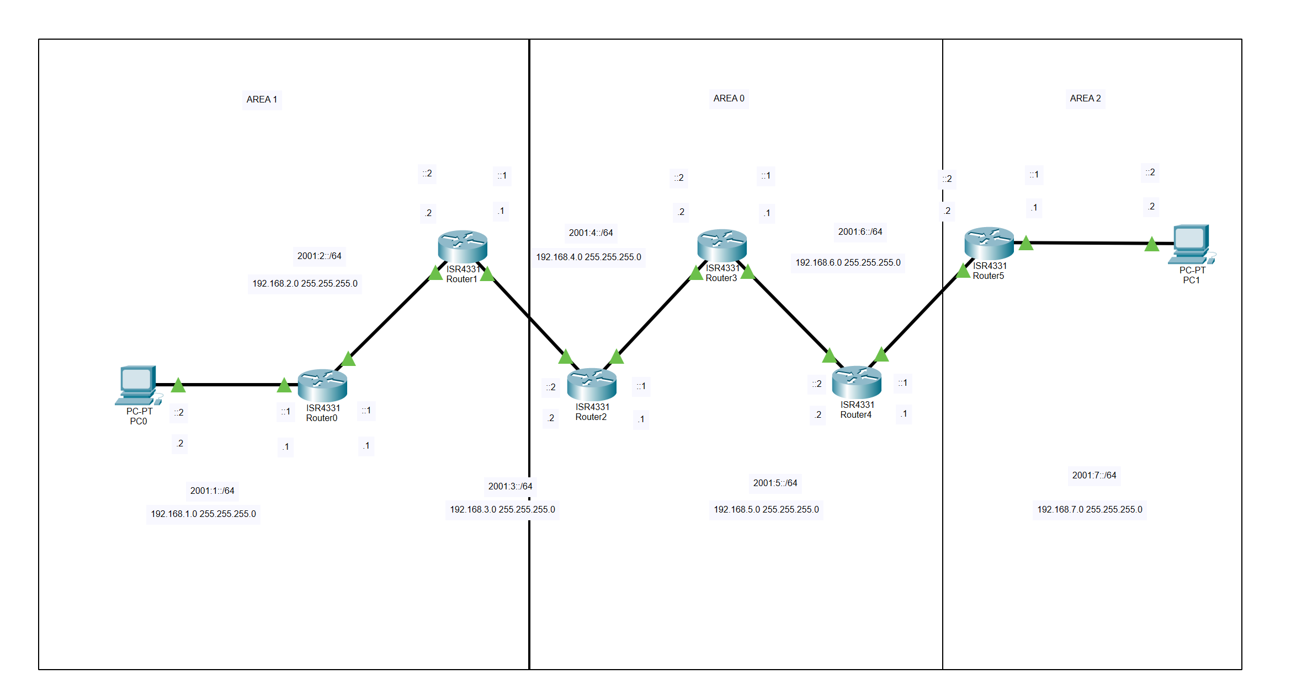

**Lab Commands**

OSPFv2 Configuration

* Router (config-router)#network 192.168.4.0 0.0.0.255 area 0

0 is the backbone area and all areas should be connected to an area 0 to cross areas

OSPFv3 Configuration

* Router(config-if)#ipv6 ospf 1 area 0

0 is the backbone area and all areas should be connected to an area 0 to cross areas

**Router Configurations**

R1 Configuration

Current configuration : 1841 bytes

!

Last configuration change at 21:47:35 UTC Tue Sep 20 2022

!

version 16.7

service timestamps debug datetime msec

service timestamps log datetime msec

platform qfp utilization monitor load 80

no platform punt-keepalive disable-kernel-core

!

hostname R1

!

boot-start-marker

boot-end-marker

!

vrf definition Mgmt-intf

!

address-family ipv4

exit-address-family

!

address-family ipv6

exit-address-family

!

no aaa new-model

!

no ip domain lookup

!

subscriber templating

vtp domain cisco

vtp mode transparent

ipv6 unicast-routing

!

multilink bundle-name authenticated

!

license udi pid ISR4321/K9 sn FDO220523GF

no license smart enable

diagnostic bootup level minimal

!

spanning-tree extend system-id

!

redundancy

mode none

!

interface GigabitEthernet0/0/0

ip address 192.168.2.1 255.255.255.0

negotiation auto

ipv6 address 2001:2::1/64

ipv6 ospf 1 area 1

!

interface GigabitEthernet0/0/1

ip address 192.168.1.1 255.255.255.0

negotiation auto

ipv6 address 2001:1::1/64

ipv6 ospf 1 area 1

!

interface Serial0/1/0

!

interface Serial0/1/1

!

interface GigabitEthernet0/2/0

no ip address

shutdown

negotiation auto

!

interface GigabitEthernet0/2/1

no ip address

shutdown

negotiation auto

!

interface GigabitEthernet0

vrf forwarding Mgmt-intf

no ip address

shutdown

negotiation auto

!

router ospf 1

router-id 1.1.1.1

network 192.168.1.0 0.0.0.255 area 1

network 192.168.2.0 0.0.0.255 area 1

!

ip forward-protocol nd

ip http server

ip http authentication local

ip http secure-server

ip tftp source-interface GigabitEthernet0

!

ipv6 router ospf 1

router-id 1.1.1.1

!

control-plane

!

line con 0

transport input none

stopbits 1

line aux 0

stopbits 1

line vty 0 4

login

!

wsma agent exec

!

wsma agent config

!

wsma agent filesys

!

wsma agent notify

!

end

R2 Configuration

Current configuration : 4035 bytes

!

Last configuration change at 20:14:34 UTC Thu Sep 22 2022

!

version 16.9

service timestamps debug datetime msec

service timestamps log datetime msec

platform qfp utilization monitor load 80

platform punt-keepalive disable-kernel-core

!

hostname R2

!

boot-start-marker

boot-end-marker

!

vrf definition Mgmt-intf

!

address-family ipv4

exit-address-family

!

address-family ipv6

exit-address-family

!

no aaa new-model

!

no ip domain lookup

!

login on-success log

!

subscriber templating

vtp domain cisco

vtp mode transparent

ipv6 unicast-routing

multilink bundle-name authenticated

!

crypto pki trustpoint TP-self-signed-2189345785

enrollment selfsigned

subject-name cn=IOS-Self-Signed-Certificate-2189345785

revocation-check none

rsakeypair TP-self-signed-2189345785

!

crypto pki certificate chain TP-self-signed-2189345785

certificate self-signed 01

30820330 30820218 A0030201 02020101 300D0609 2A864886 F70D0101 05050030

31312F30 2D060355 04031326 494F532D 53656C66 2D536967 6E65642D 43657274

69666963 6174652D 32313839 33343537 3835301E 170D3232 30393230 32303534

32345A17 0D333030 31303130 30303030 305A3031 312F302D 06035504 03132649

4F532D53 656C662D 5369676E 65642D43 65727469 66696361 74652D32 31383933

34353738 35308201 22300D06 092A8648 86F70D01 01010500 0382010F 00308201

0A028201 0100B827 85483C93 CE65CC15 5B61579C C1E973E9 342F4BB9 81EE2059

23A2477F 0361A78E 3BF3A688 E5FEE9B8 BBB616C9 26549F4C A8FCF553 F4A2D9B7

B77FD2ED BCF2F4BF 857F3BF7 AB324F7F 7F77D730 77685D3B 4742282A 8179FDE2

D12AB193 41B2AFB9 371ACB0B 9CF19352 203239BE AA043282 347504D6 7E38682C

ED7E4A7D 29F4ED1A 4B74FD55 EAE81380 04910989 9BDC215C E64C1782 03F10FBC

256B35CC CF4C6D5C B59927F9 A9DD21AF 9D146434 548B7108 9CEF5D0C EF87C5C8

61D648BE 8723D486 2CC1EB6F 9FC0A37F 8F6E5F0F 8F949B19 EA927A0B 69222192

4ACB4FE5 A0977BCA A2418C49 8E8FE22E 70AB64B7 8FF9B7A2 1C15F7AE 569C0F75

8C03F1A7 96570203 010001A3 53305130 0F060355 1D130101 FF040530 030101FF

301F0603 551D2304 18301680 1400A1AE 12828C1E C2C4DD05 69EB426A DF347326

69301D06 03551D0E 04160414 00A1AE12 828C1EC2 C4DD0569 EB426ADF 34732669

300D0609 2A864886 F70D0101 05050003 82010100 61401242 1D169A21 A09678CE

998933B2 086312B9 AD245954 011F0872 FB3EED46 6176F0F1 7889A7EF 76C44102

095E8772 992B3C47 9E47DB0F D50A0620 55D0DEF8 B595770D 9F6AB481 4355E88E

B1EAA777 724A579E 9293C010 2C693421 E7F9740E 5E09DDC1 F50A88DA 7ADC83C0

F4B50EBC F05DC3FD C252E1A6 08BD2DAB 17924781 7C7D9CC7 12E58A88 F59D62C2

F8EA64DB 41CF3AF7 404AE5F1 94A7DA32 8FDFF641 22DA2610 BB763580 E9353D25

8457EF63 0DAF6FDA E6D36BAB F0D21F9D 984A8051 3B88E676 9B7F2369 7DA87DBD

095714FC F58AE4D0 28474A4D 0BCD43B9 AF5CDDA8 33887834 0B55FF1E 63FAF77F

4BDDF75A B8024408 93E8CB69 24F1C0B1 8003F338

quit

!

license udi pid ISR4321/K9 sn FDO21482DXE

no license smart enable

diagnostic bootup level minimal

!

spanning-tree extend system-id

!

redundancy

mode none

!

interface GigabitEthernet0/0/0

ip address 192.168.3.1 255.255.255.0

negotiation auto

ipv6 address 2001:3::1/64

ipv6 ospf 1 area 0

!

interface GigabitEthernet0/0/1

ip address 192.168.2.2 255.255.255.0

negotiation auto

ipv6 address 2001:2::2/64

ipv6 ospf 1 area 1

!

interface Serial0/1/0

no ip address

shutdown

!

interface Serial0/1/1

no ip address

shutdown

!

interface GigabitEthernet0/2/0

no ip address

shutdown

negotiation auto

!

interface GigabitEthernet0/2/1

no ip address

shutdown

negotiation auto

!

interface GigabitEthernet0

vrf forwarding Mgmt-intf

no ip address

shutdown

negotiation auto

!

router ospf 1

router-id 2.2.2.2

network 192.168.2.0 0.0.0.255 area 1

network 192.168.3.0 0.0.0.255 area 0

!

ip forward-protocol nd

ip http server

ip http authentication local

ip http secure-server

ip tftp source-interface GigabitEthernet0

!

ipv6 router ospf 1

router-id 2.2.2.2

!

control-plane

!

line con 0

transport input none

stopbits 1

line aux 0

stopbits 1

line vty 0 4

login

!

End

R3 Configuration

Current configuration : 4035 bytes

!

Last configuration change at 22:01:02 UTC Tue Sep 20 2022

!

version 16.9

service timestamps debug datetime msec

service timestamps log datetime msec

platform qfp utilization monitor load 80

platform punt-keepalive disable-kernel-core

!

hostname R3

!

boot-start-marker

boot-end-marker

!

vrf definition Mgmt-intf

!

address-family ipv4

exit-address-family

!

address-family ipv6

exit-address-family

!

no aaa new-model

!

no ip domain lookup

!

login on-success log

!

subscriber templating

vtp domain cisco

vtp mode transparent

ipv6 unicast-routing

multilink bundle-name authenticated

!

crypto pki trustpoint TP-self-signed-2557841031

enrollment selfsigned

subject-name cn=IOS-Self-Signed-Certificate-2557841031

revocation-check none

rsakeypair TP-self-signed-2557841031

!

crypto pki certificate chain TP-self-signed-2557841031

certificate self-signed 01

30820330 30820218 A0030201 02020101 300D0609 2A864886 F70D0101 05050030

31312F30 2D060355 04031326 494F532D 53656C66 2D536967 6E65642D 43657274

69666963 6174652D 32353537 38343130 3331301E 170D3232 30393230 32303339

34355A17 0D333030 31303130 30303030 305A3031 312F302D 06035504 03132649

4F532D53 656C662D 5369676E 65642D43 65727469 66696361 74652D32 35353738

34313033 31308201 22300D06 092A8648 86F70D01 01010500 0382010F 00308201

0A028201 0100AD30 DE89012B B96073C5 ABF06064 A41866D0 DD979669 40F203D8

1D8FA1D9 811E0FBD 2B32AF45 EB10B004 0A79C29B 4D9E4ECF 609068EF 11BF88A8

B2601E10 1B706416 5F0211C7 70129191 D0D9CFF5 56BEB211 A95F8831 1EC9A1E9

1700A5EC 54DD6A24 51B1802A DA81D79A 583043A7 0277AF3C AC575D80 D2431943

09AC77A7 46F48A55 E5537F4B 3263DCFE 64787EDC F1B03D33 4F581298 CC595C11

AFBB54D6 707E21A8 F1BC7BDB 4295AA4C 1D4A776F 30C845C6 193D154C D66E66D3

A941536C 85921712 313664E9 A7883587 57E802E5 49319FA2 D195067C B18513E8

96E3624B CFA3382E 7AC5E51D 72F54AC6 D6141609 786B1C65 704E7861 B21A8C1A

D547BEF1 A7A30203 010001A3 53305130 0F060355 1D130101 FF040530 030101FF

301F0603 551D2304 18301680 14809F55 FAA4C593 70972A09 12B10AF9 3A635C28

C0301D06 03551D0E 04160414 809F55FA A4C59370 972A0912 B10AF93A 635C28C0

300D0609 2A864886 F70D0101 05050003 82010100 4C866C94 DF1484D0 D050336F

6527AA39 F35E2953 42002186 B3EFBAE2 0643F491 B817CC40 8D7145BD FF6C0301

9DCC7E79 AE478691 A3729389 B31D4FDC D6FDA368 086C5CDD EA902A33 B0B419CE

4EFA5D8F 241A984C F1A814BD 09C12DE4 52BAFE58 D91A76CD A6F1FE2B C17E5227

AB0FF127 FFE6D97C 4C3BE792 1E3CA86D B430F5A7 D845F146 E900E90A 9738BB2B

4DC5A8F3 A8F03862 E4C25749 8C6996FF F045D39B 626C35EB 73CB2B45 10078457

0A4E8440 BEC4EE6E 1D1562EA E090F61B CCD7711F 503FD549 BA33E800 386E5508

0BA1CC13 B75FC49D 6202A231 5B899C80 D2EE0673 39885FA9 6B13BC2D A2EBDD94

E1BF5C43 0BA3E467 129B2157 4863C7DF E122BD8D

quit

!

license udi pid ISR4321/K9 sn FDO21500G1N

no license smart enable

diagnostic bootup level minimal

!

spanning-tree extend system-id

!

redundancy

mode none

!

interface GigabitEthernet0/0/0

ip address 192.168.4.1 255.255.255.0

negotiation auto

ipv6 address 2001:4::1/64

ipv6 ospf 1 area 0

!

interface GigabitEthernet0/0/1

ip address 192.168.3.2 255.255.255.0

negotiation auto

ipv6 address 2001:3::2/64

ipv6 ospf 1 area 0

!

interface Serial0/1/0

no ip address

shutdown

!

interface Serial0/1/1

no ip address

shutdown

!

interface GigabitEthernet0/2/0

no ip address

shutdown

negotiation auto

!

interface GigabitEthernet0/2/1

no ip address

shutdown

negotiation auto

!

interface GigabitEthernet0

vrf forwarding Mgmt-intf

no ip address

shutdown

negotiation auto

!

router ospf 1

router-id 3.3.3.3

network 192.168.3.0 0.0.0.255 area 0

network 192.168.4.0 0.0.0.255 area 0

!

ip forward-protocol nd

ip http server

ip http authentication local

ip http secure-server

ip tftp source-interface GigabitEthernet0

!

ipv6 router ospf 1

router-id 3.3.3.3

!

control-plane

!

line con 0

transport input none

stopbits 1

line aux 0

stopbits 1

line vty 0 4

login

!

end

R4 Configuration

Current configuration : 1659 bytes

!

Last configuration change at 21:22:02 UTC Tue Sep 20 2022

!

version 15.5

service timestamps debug datetime msec

service timestamps log datetime msec

no platform punt-keepalive disable-kernel-core

!

hostname R4

!

boot-start-marker

boot-end-marker

!

vrf definition Mgmt-intf

!

address-family ipv4

exit-address-family

!

address-family ipv6

exit-address-family

!

no aaa new-model

!

no ip domain lookup

!

ipv6 unicast-routing

!

subscriber templating

vtp domain cisco

vtp mode transparent

multilink bundle-name authenticated

!

license udi pid ISR4321/K9 sn FDO21441WDF

!

spanning-tree extend system-id

!

redundancy

mode none

!

vlan internal allocation policy ascending

!

vlan 10

name Apple

!

vlan 20

name Facebook

!

interface GigabitEthernet0/0/0

ip address 192.168.5.1 255.255.255.0

negotiation auto

ipv6 address 2001:5::1/64

ipv6 ospf 1 area 0

!

interface GigabitEthernet0/0/1

ip address 192.168.4.2 255.255.255.0

negotiation auto

ipv6 address 2001:4::2/64

ipv6 ospf 1 area 0

!

interface Serial0/1/0

no ip address

shutdown

!

interface Serial0/1/1

no ip address

shutdown

!

interface GigabitEthernet0

vrf forwarding Mgmt-intf

no ip address

shutdown

negotiation auto

!

interface Vlan1

no ip address

shutdown

!

router ospf 1

router-id 4.4.4.4

network 192.168.4.0 0.0.0.255 area 0

network 192.168.5.0 0.0.0.255 area 0

!

ip forward-protocol nd

no ip http server

no ip http secure-server

ip tftp source-interface GigabitEthernet0

!

ipv6 router ospf 1

router-id 4.4.4.4

!

control-plane

!

line con 0

stopbits 1

line aux 0

stopbits 1

line vty 0 4

login

!

end

R5 Configuration

Current configuration : 1609 bytes

!

Last configuration change at 21:27:07 UTC Tue Sep 20 2022

!

version 15.5

service timestamps debug datetime msec

service timestamps log datetime msec

no platform punt-keepalive disable-kernel-core

!

hostname R5

!

boot-start-marker

boot-end-marker

!

vrf definition Mgmt-intf

!

address-family ipv4

exit-address-family

!

address-family ipv6

exit-address-family

!

no aaa new-model

!

no ip domain lookup

!

ipv6 unicast-routing

!

subscriber templating

vtp domain cisco

vtp mode transparent

multilink bundle-name authenticated

!

license udi pid ISR4321/K9 sn FDO214420HM

!

spanning-tree extend system-id

!

redundancy

mode none

!

!vlan internal allocation policy ascending

!

vlan 10

name Apple

!

vlan 20

name Facebook

!

interface GigabitEthernet0/0/0

ip address 192.168.6.1 255.255.255.0

negotiation auto

ipv6 address 2001:6::1/64

ipv6 ospf 1 area 2

!

interface GigabitEthernet0/0/1

ip address 192.168.5.2 255.255.255.0

negotiation auto

ipv6 address 2001:5::2/64

ipv6 ospf 1 area 0

!

interface Serial0/1/0

!

interface Serial0/1/1

!

interface GigabitEthernet0

vrf forwarding Mgmt-intf

no ip address

shutdown

negotiation auto

!

interface Vlan1

no ip address

shutdown

!

router ospf 1

router-id 5.5.5.5

network 192.168.5.0 0.0.0.255 area 0

network 192.168.6.0 0.0.0.255 area 2

!

ip forward-protocol nd

no ip http server

no ip http secure-server

ip tftp source-interface GigabitEthernet0

!

ipv6 router ospf 1

router-id 5.5.5.5

!

control-plane

!

line con 0

stopbits 1

line aux 0

stopbits 1

line vty 0 4

login

!

end

R6 Configuration

Current configuration : 1524 bytes

!

Last configuration change at 21:14:19 UTC Tue Sep 20 2022

!

version 15.5

service timestamps debug datetime msec

service timestamps log datetime msec

no platform punt-keepalive disable-kernel-core

!

hostname R6

!

boot-start-marker

boot-end-marker

!

vrf definition Mgmt-intf

!

address-family ipv4

exit-address-family

!

address-family ipv6

exit-address-family

!

no aaa new-model

!

no ip domain lookup

!

ipv6 unicast-routing

!

subscriber templating

multilink bundle-name authenticated

!

license udi pid ISR4321/K9 sn FDO214414DZ

!

spanning-tree extend system-id

!

redundancy

mode none

!

vlan internal allocation policy ascending

!

interface GigabitEthernet0/0/0

ip address 192.168.7.1 255.255.255.0

negotiation auto

ipv6 address 2001:7::1/64

ipv6 ospf 1 area 2

!

interface GigabitEthernet0/0/1

ip address 192.168.6.2 255.255.255.0

negotiation auto

ipv6 address 2001:6::2/64

ipv6 ospf 1 area 2

!

interface Serial0/1/0

!

interface Serial0/1/1

!

interface GigabitEthernet0

vrf forwarding Mgmt-intf

no ip address

shutdown

negotiation auto

!

interface Vlan1

no ip address

shutdown

!

router ospf 1

router-id 6.6.6.6

network 192.168.6.0 0.0.0.255 area 2

network 192.168.7.0 0.0.0.255 area 2

!

ip forward-protocol nd

no ip http server

no ip http secure-server

ip tftp source-interface GigabitEthernet0

!

ipv6 router ospf 1

router-id 6.6.6.6

!

control-plane

!

line con 0

stopbits 1

line aux 0

stopbits 1

line vty 0 4

login

!

end

**Trace Routes**

IPv4 Trace Route

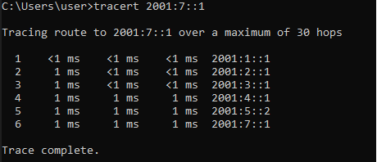

IPv6



**Show Routes**

IPv4

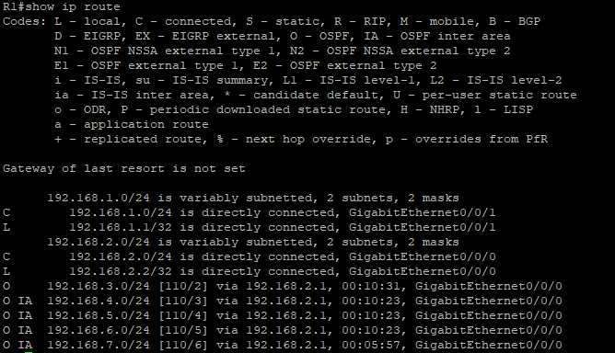

IPv6

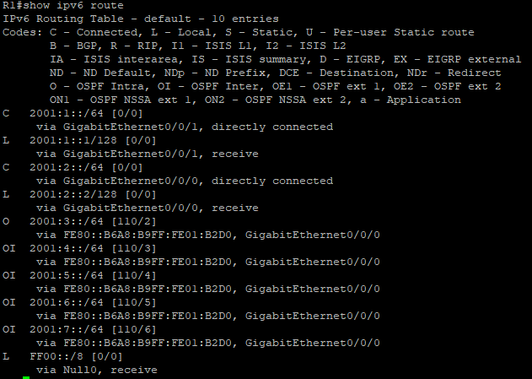

**Pings Between PCs**

IPv4

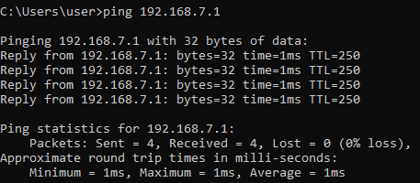

IPv6

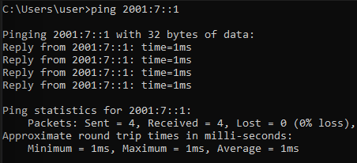

**Problems**

We tried setting up OSPF to not have Area 0 be the backbone and instead we were using Area 1. This created issues as networks had to be connected using Area 0 and it took us while to find and fix this issue.

**Conclusion**

In conclusion we made IPv4 and IPv6 networks in 3 areas for Multi-area OSPF v2 and v3 across 6 routers. We had to combine 3 areas so that a pc in one area could connect to the furthest area through area 0 to the other area connected to area 0 pc.